INDIAN AGRICULTURE CROP PRODUCTION

Introduction:

Overview:

Our project topic is indian agriculture crop production .we create several data analysics by the given data about agriculture crop production.

Purpose:

We learned some basic concept about the tableau and data analysics by this project .

Problem Definition &Design Thinking :

Empathy Map:

In Empathy map we include several question asked by the farmer about agriculture production by this empathy map we have clarified and analysed the farmer doubts about agriculture production.

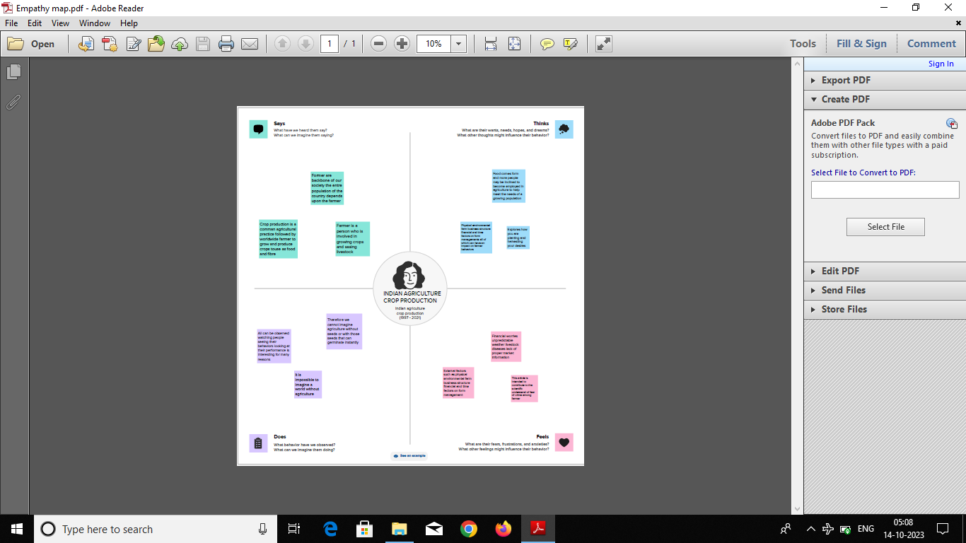

Ideation & Brainstorming Map:

In Brainstorming map we have explained the various problem suffered by the farmer modern technology _based farming available in the agriculture production production by this brainstorming map the farmer can easily get knowledge about this project.

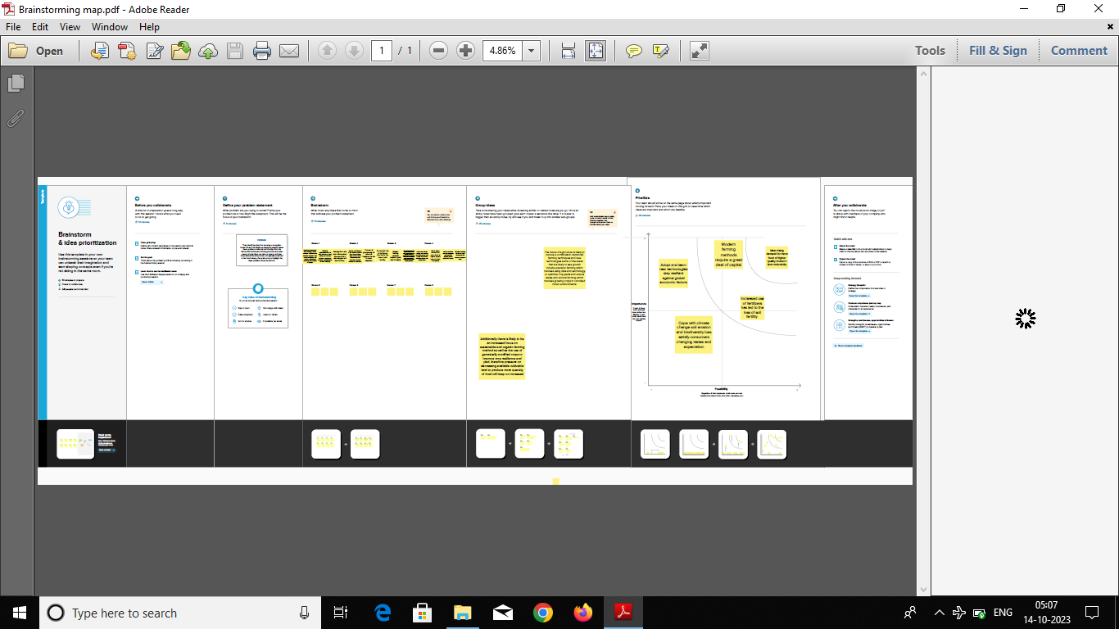

Result:

Finally we can analysics all the information about the agriculture such as yield by season,statewise production,crops ,production by are,major yielding crops, cultivation all over all the world etc.

From these information we have created a dashboard and the story from data ,collected by the dataset by the help of tableau.

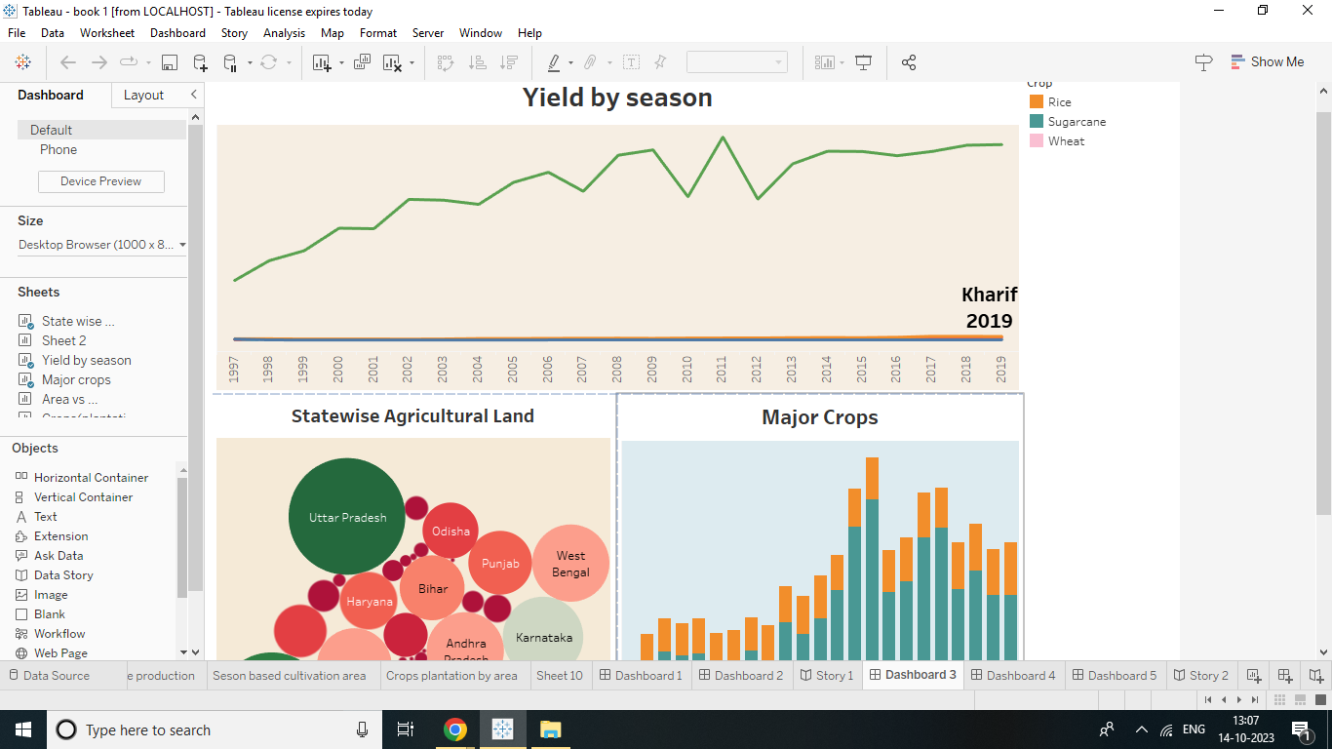

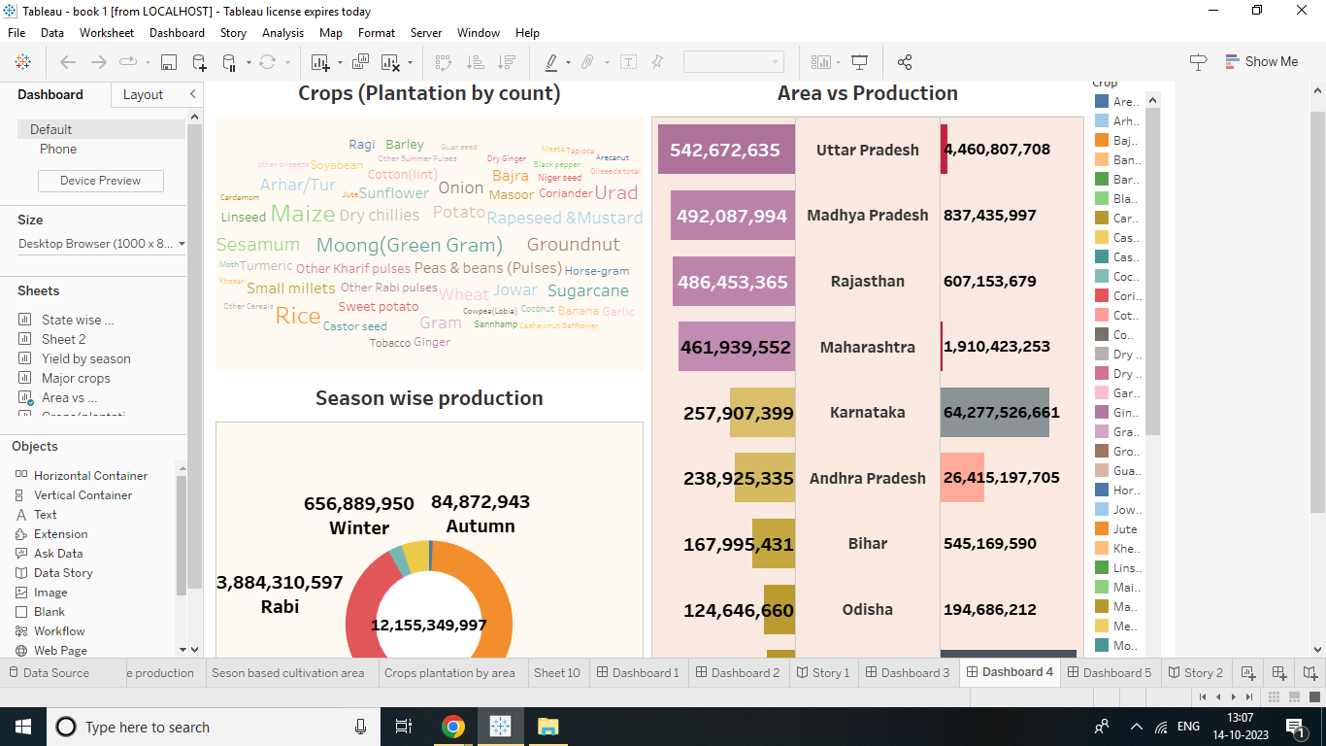

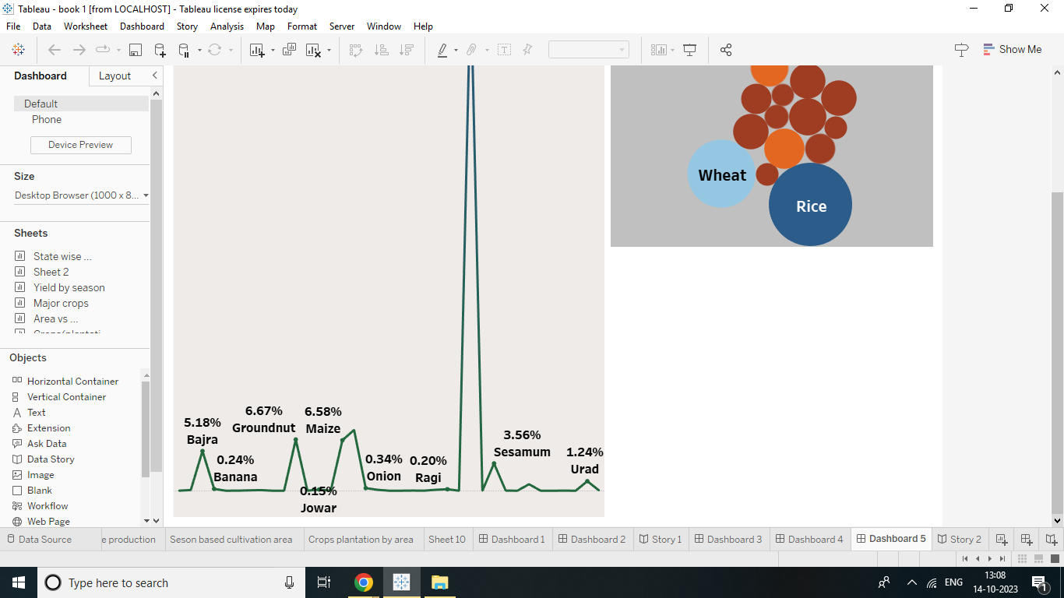

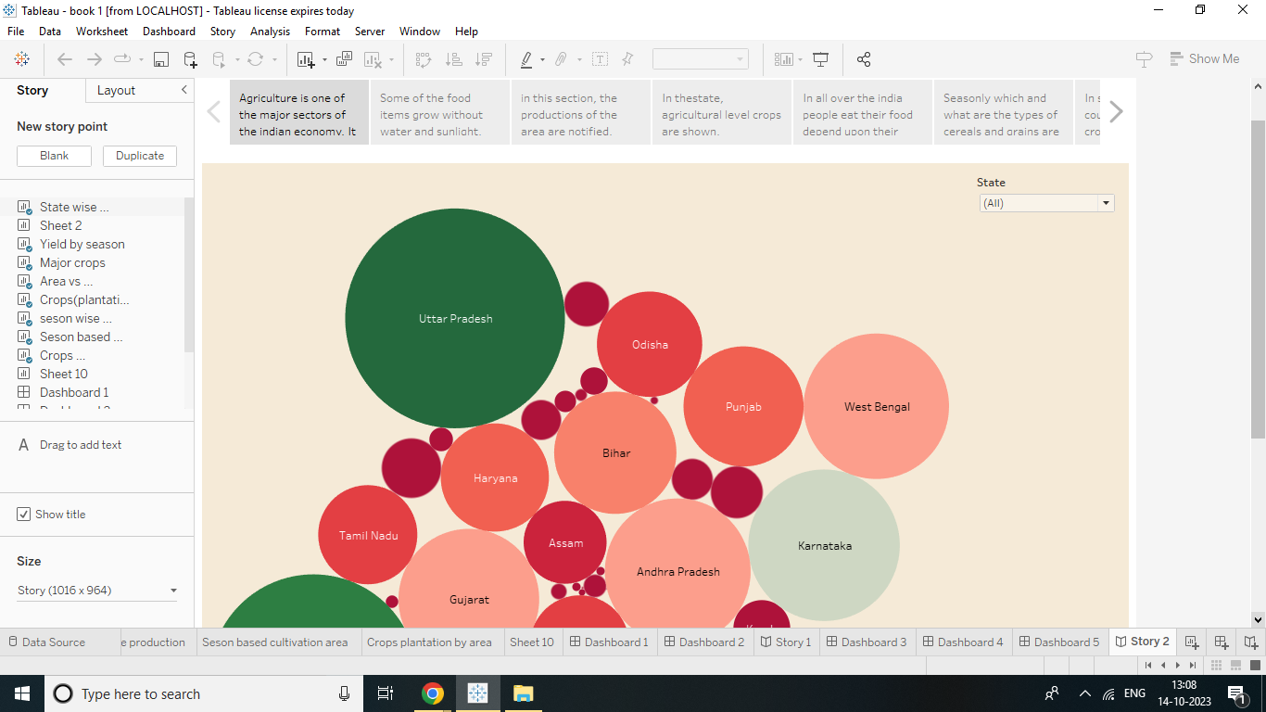

Advantage & Disadvantage:

* It is used for providing raw materials for food and others production.
* It improves soil structure ,percolation and reduces the change of creation of hard-pan in sub soil also reduce soil erosion .
* Machines are helpfull for planting the seeds.
* Agriculture is the backbone of are country economy.
* The disadvantage of agriculture are environment degradation depletion of natural resourse.
* The use of pesticides and fertilizers can harm human health and the environment

Applications:

* Agriculture leads to cultivationg modifying the soil
* Production of crops and it is used for harvesting the field.
* Agriculture Gls tools can identify the vegetation level in our field .
* Precision farming animal menitening and greenhouse monitoring and greenhouse monitoring are.
* The main factors of production such as water ,soil,land , rainfall are very much.

Conclusion:

From this project ,we get more details about date analysics and how to work in tableau .It will help us for our future studies.

Future Scope:

Agriculture is good for the future as it is expected to use advanced technologies and innovations to produce more food with limited land and resourses, increase efficiency on farms and become more profitable ,efficient ,safe and environment friendly.